Experiment-3

**Aim:** To create a docker network and configure multiple containers over that network and assure connectivity among them

**Now follow the steps under neath.**

**Step1:** Create a docker network.

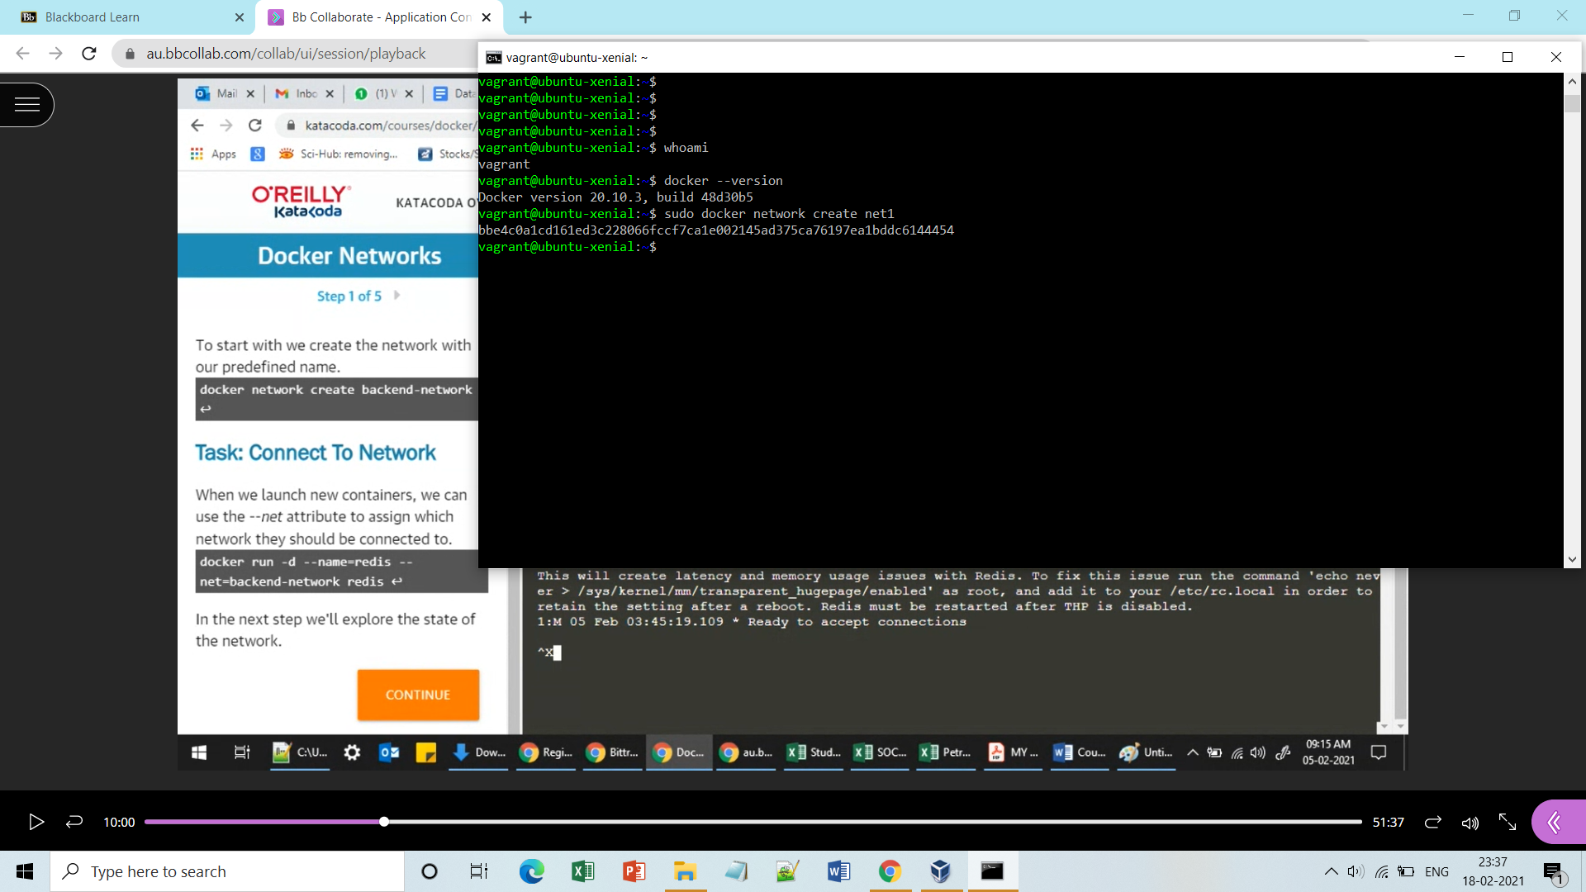

**Step2:** Check whether network is created or not and run a container in background over the same network. 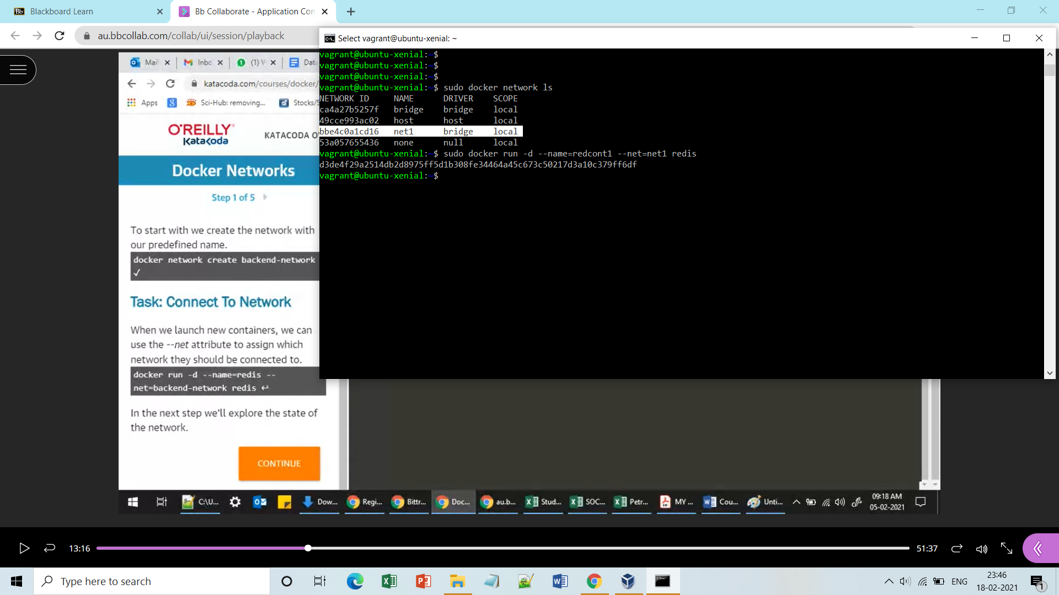

**Step3:** Now inspect that container and get its ip.

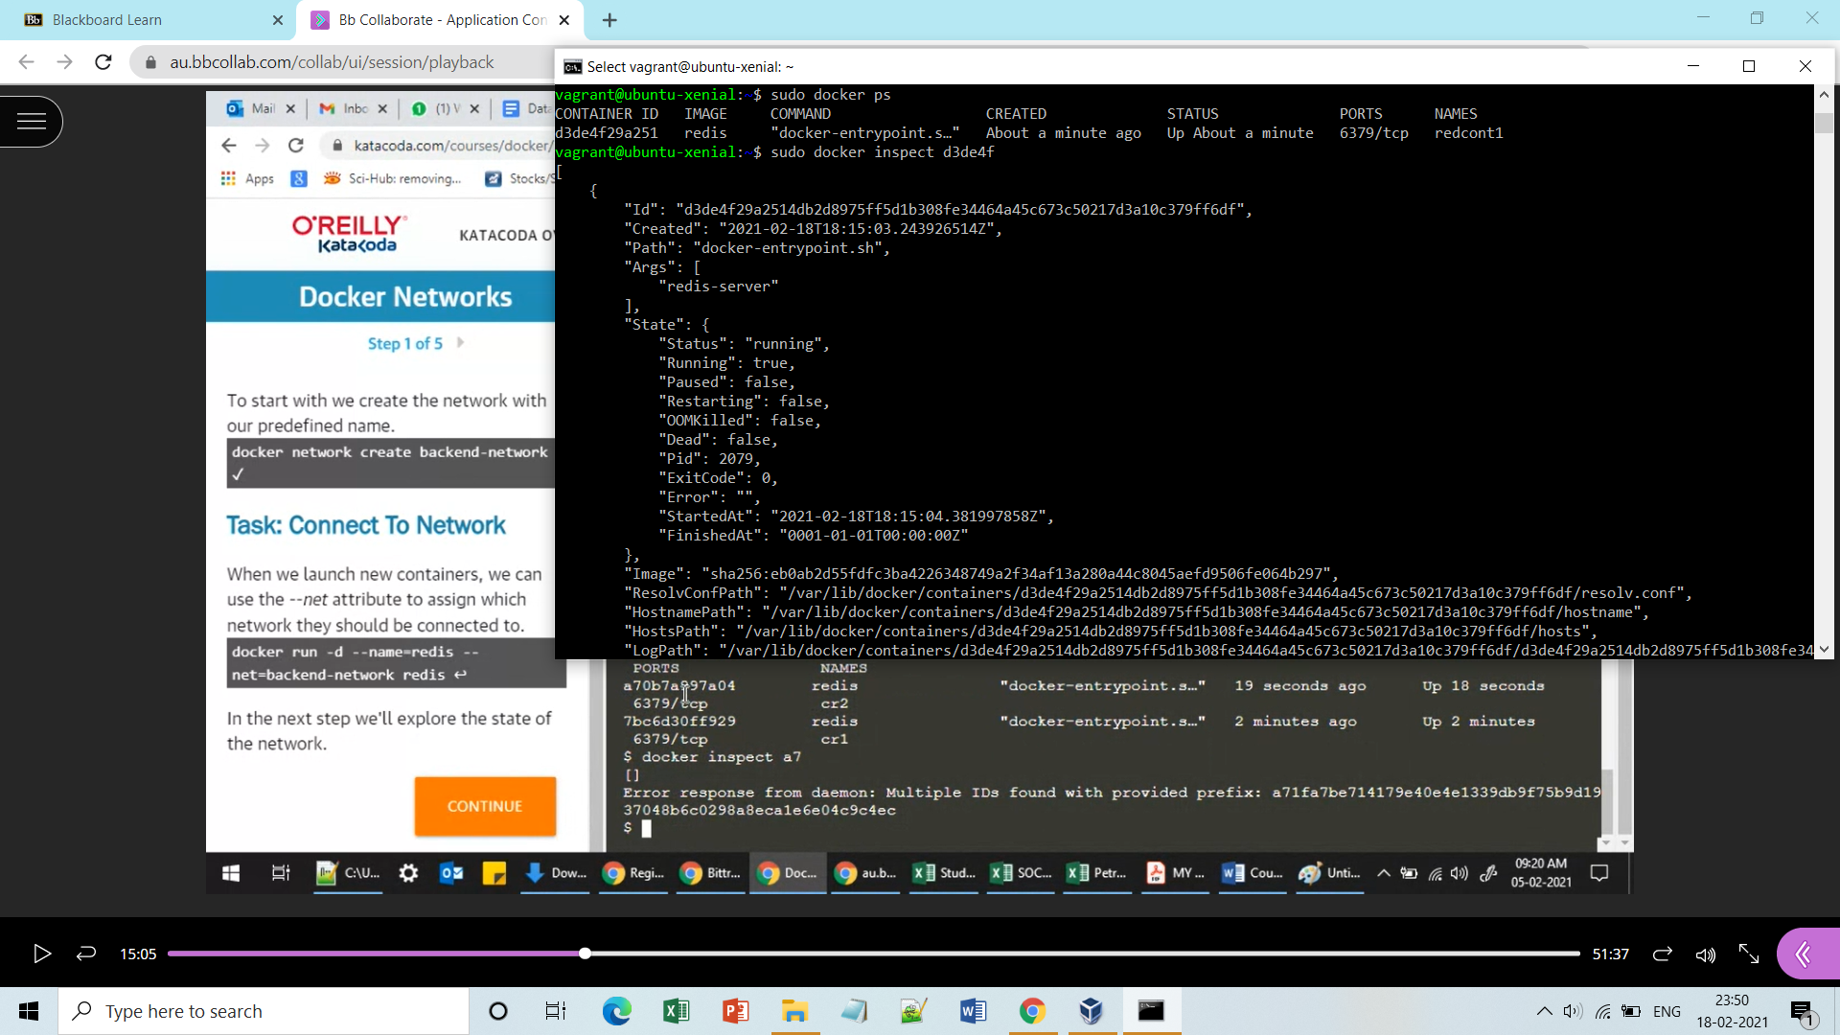

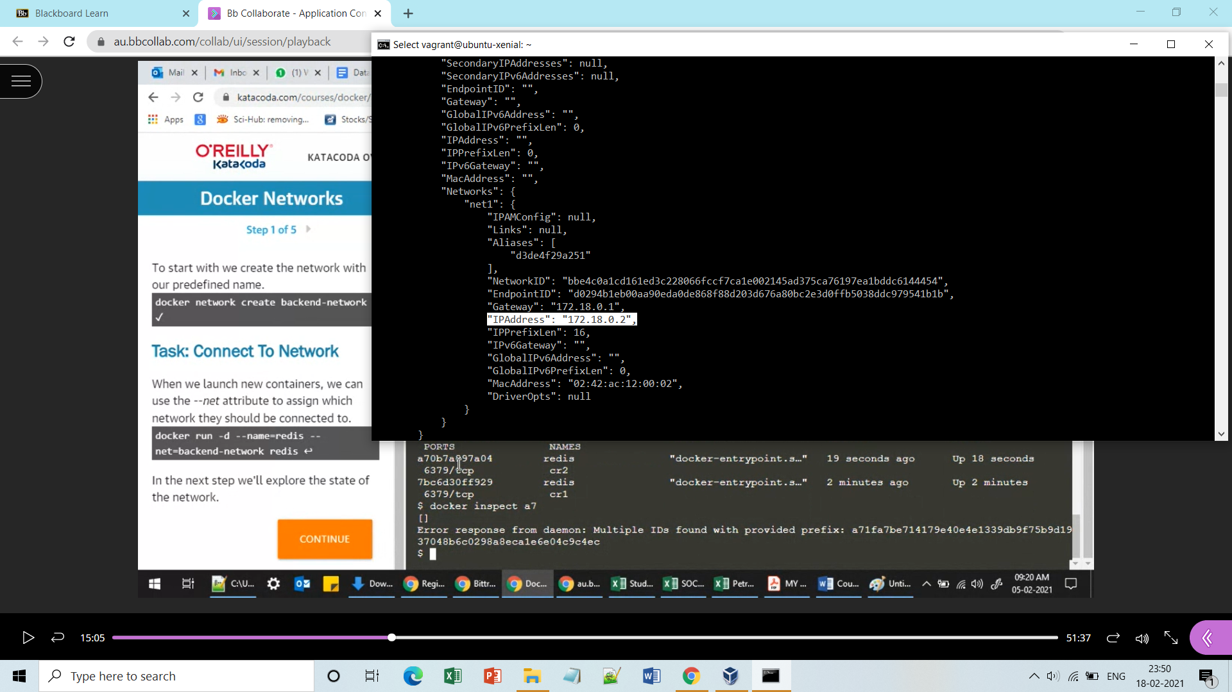

**Step4:** Now make another container another container over the same network and get its ip (should be different from prior one but of same range.)

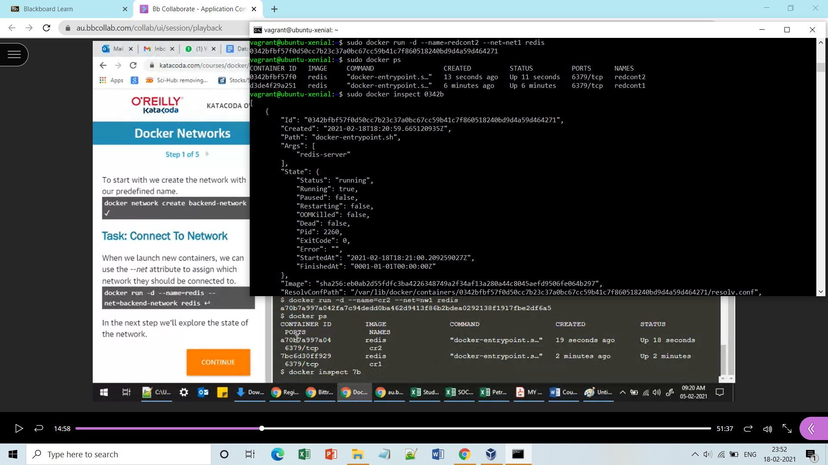

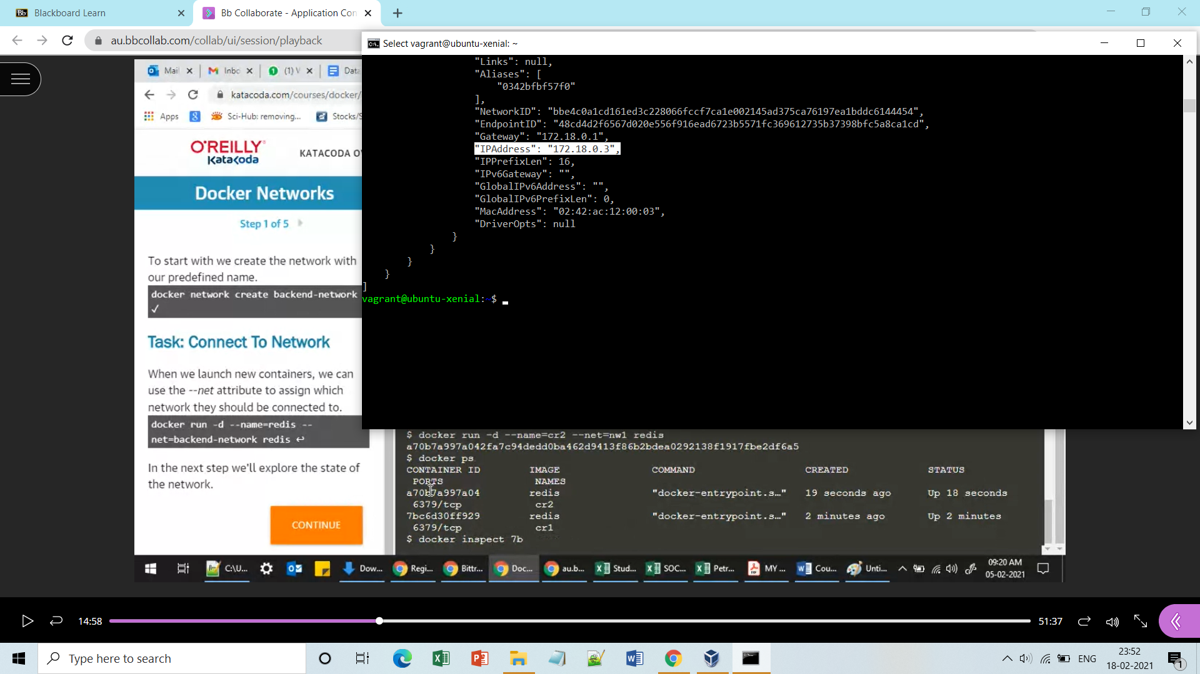

**Step5:** Now check the host and configuration files by running and alpine image over the same created network, before actually pinging the other two containers.

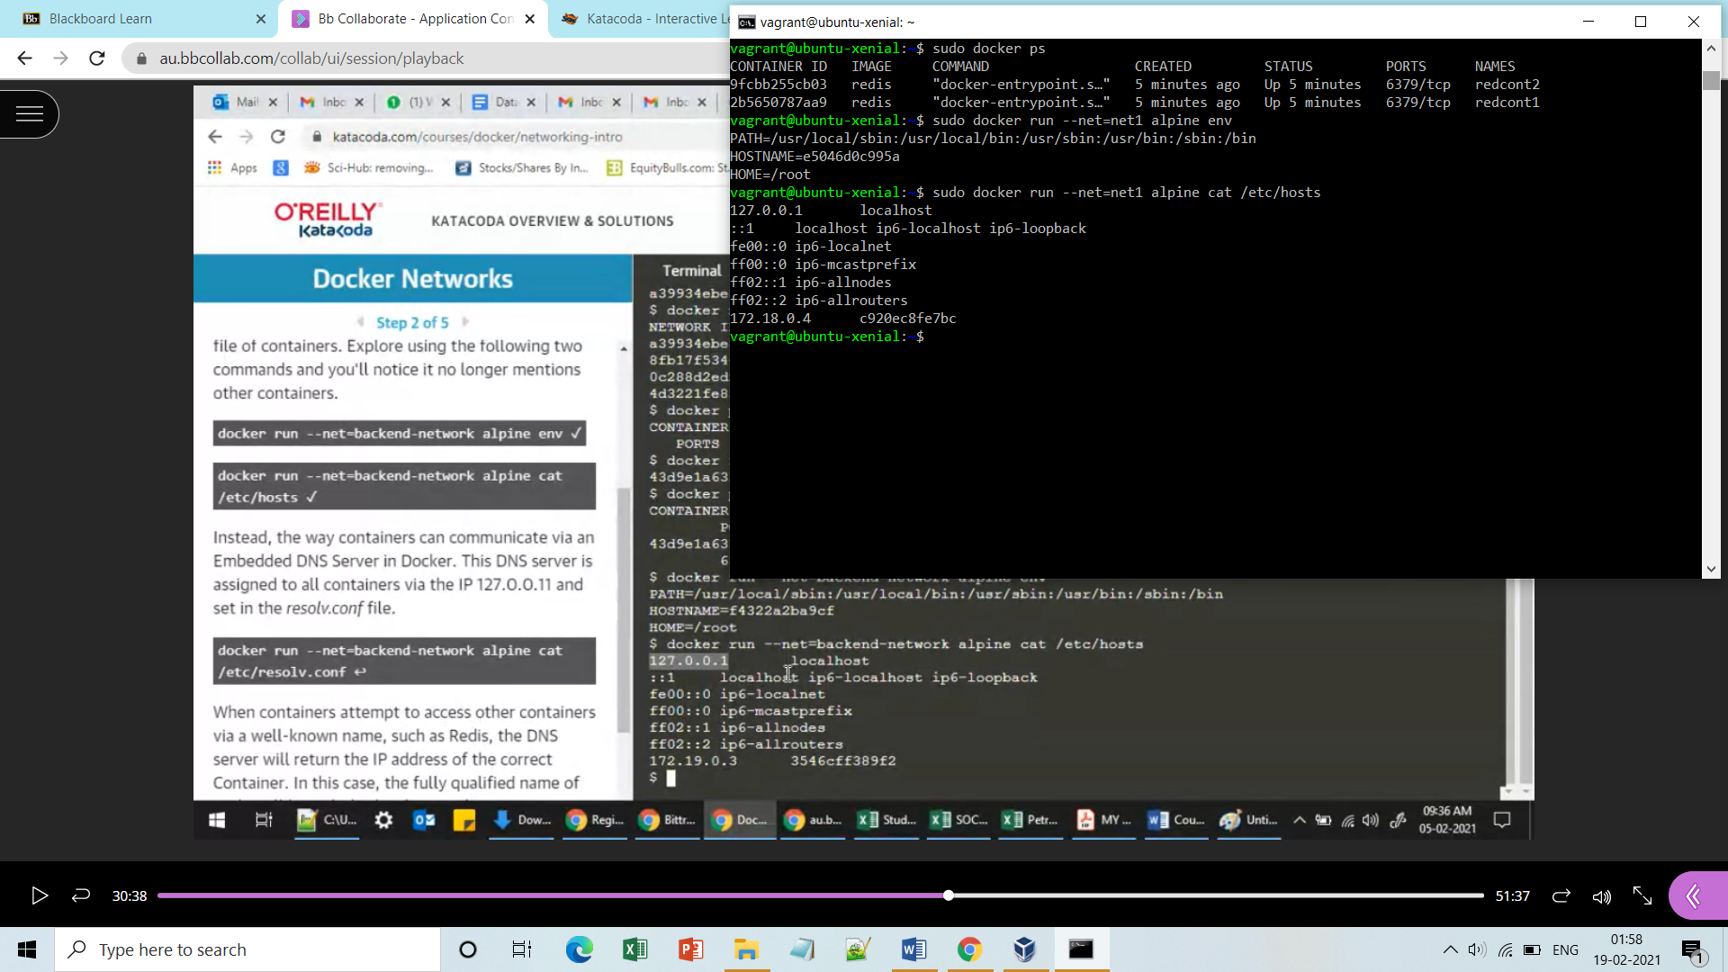

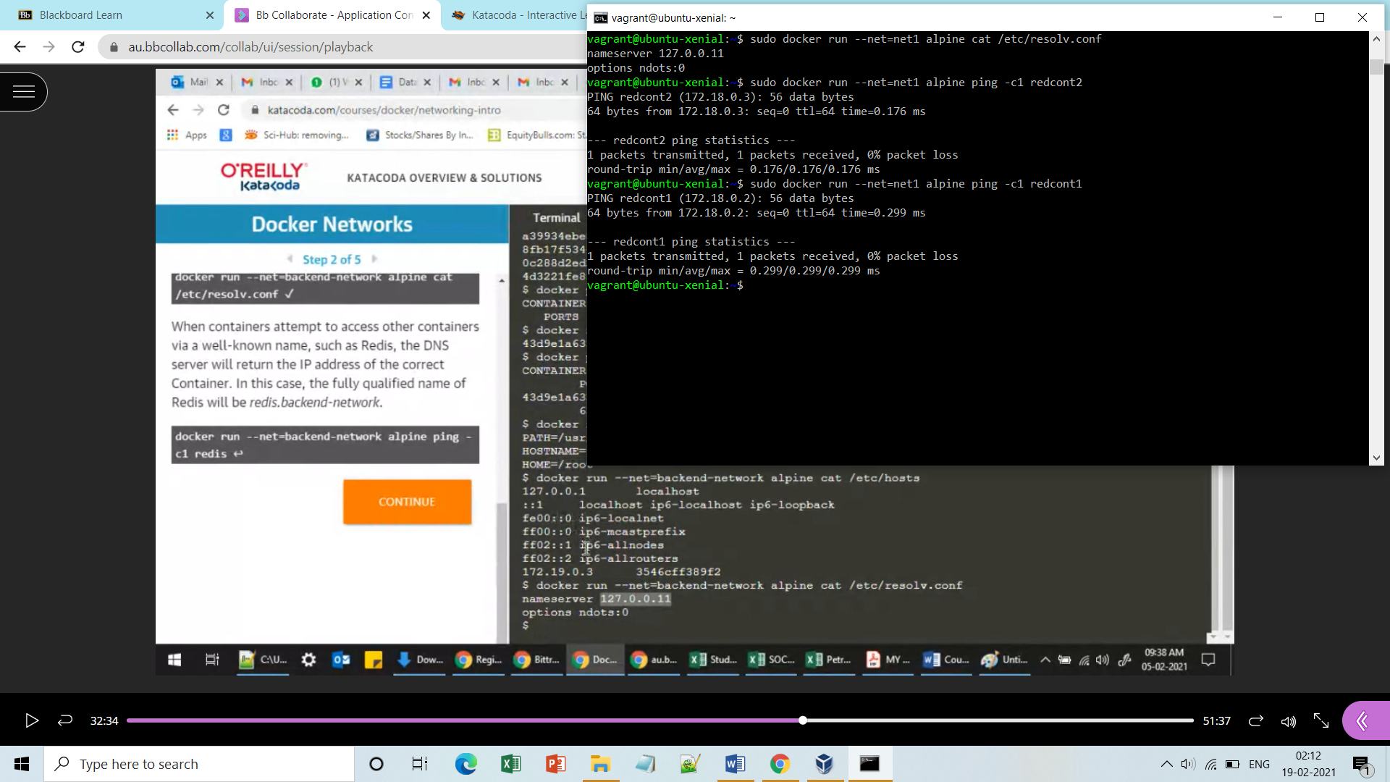

**Done!!**

**Now in order to deploy a webserver in any container, run the following commands.**

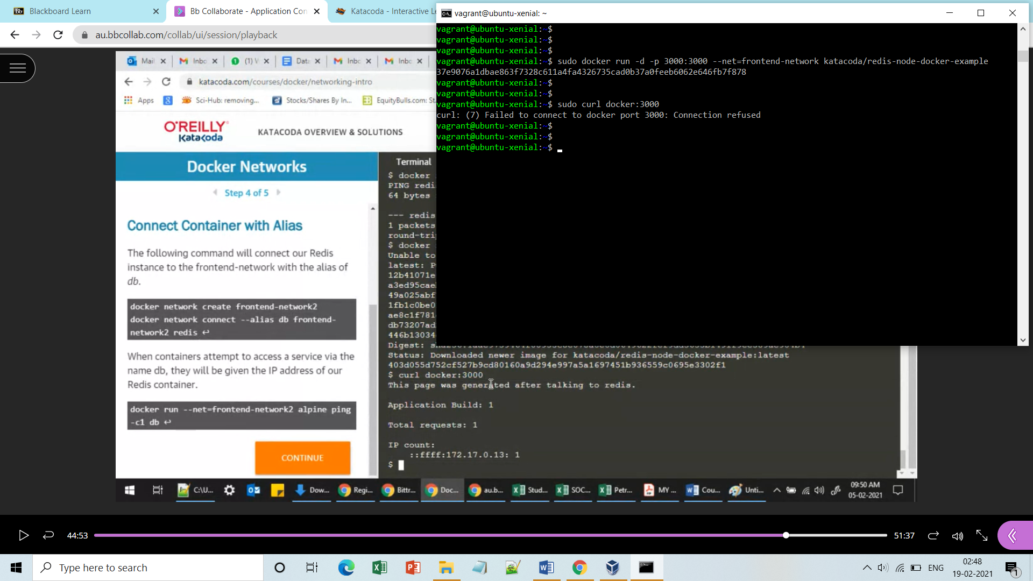

**Note:-** My hostname is not correct but in your case it will run and a welcome page will open ur default browser.

**Alias:- Just way a to give another name to your container.**

